

Aditya Raj

BCIS309 – Work Integrated Learning Project,

Software Development Pathway

Semester 1, 2021

SQL Test Automation for Ara Institute of Canterbury

Methodology Essay – Version 0.5

Table of Contents

Document Control 2

Part A – Literature Review 3

Agile Methodology 3

Software Development Process 6

Part B – Industry Practice 7

Overview 7

Planning 7

Design and Development 8

Testing and Evaluation/Meeting 8

Part C – Reflections 10

Final Reflection 10

Appendix 12

Appendix A – Task Planning for Sprints 12

Appendix B – Industry Backlog 14

Appendix C – Design 15

Appendix D – Development 16

Appendix E – Testing 22

Bibliography 23

# Document Control

|  |  |  |  |
| --- | --- | --- | --- |
| Date | Author | Version | Status of Document/Updates Made |
| 1/05/2021 | Aditya Raj | V0.1 | Document Creation |
| 19/05/2021 | Aditya Raj | V0.2 | Part A - First Draft Completed & Submitted for Marking |
| 21/05/2021 | Aditya Raj | V0.3 | Final Version Submitted for Marking |
| 21/06/2021 | Aditya Raj | V0.4 | Part A Updated |
| 25/06/2021 | Aditya Raj | V0.5 | Part B and C Added – First Draft Completed |

# Part A – Literature Review

This section serves to discuss the literature review of the accepted Agile methodology with the Scrum framework involved in this project including the phases of the Software Development process.

## Agile Methodology

In the 1990s, in a time where the IT industry was not evolving fast enough to meet customer demands and requirements, the Agile methodology was introduced, a process for project management created to be used mainly for software development with a focus on demand and evolving solutions, this is possible with the collaborative effort of teams and their customers/clients. Before this, traditional development models existed for software development, for example, the Waterfall model, however, they did not involve any collaboration between the development team and the client, these models had a timeline approach in which sequential development happened and the client was only revealed the final product at the very final step, due to this, there was a higher chance of unsatisfaction from the client as they weren’t asked for feedback throughout the development process, doing this would have increased flexibility for changes to occur within the project development, rather than at the end when the project is ready (Muslihat, 2018).

The SQL Test Automation project at Ara Institute of Canterbury involves the use of this Agile methodology. This project applies the Agile methodology because of its many advantages that help satisfy the requirements of the company project unlike other methodologies such as the Waterfall which because of its linear process does not allow for constant improvement and innovation for products in the ever-changing software market. (Muslihat, 2018). These are the 12 principles of the Agile methodology that make projects superior to traditional models:

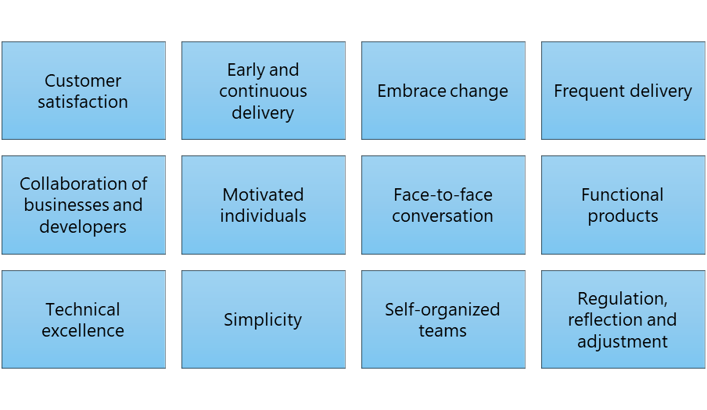

Figure 1 Principles of Agile (Business News Daily Editor, 2020)

### Scrum

The Agile process allows the team to better manage their project by organising it into many stages, allowing for continuous teamwork with the stakeholders while steadily improving the product at every stage (Business News Daily Editor, 2020), Scrum is an Agile framework that allows for useful collaborations between teams that work on products with complexity. A scrum is made up of meetings, roles and tools that help teams to work together with a better arrangement and workload management (Business News Daily Editor, 2020). Scrum provides many benefits to complicated projects by requiring teams to complete a backlog, benefits to companies that value the results and benefit companies that accommodate their customers by developing products that meet customer needs and requirements (Business News Daily Editor, 2020).

With the Agile methodology, I have implemented the Scrum framework because with it I was able to work in increments, by adding required features and making changes to the product in each sprint as per feedback from my industry supervisors. This methodology and framework combo has been easy to understand and has allowed me to prioritise important features over features that will never be used. I have put into practice these steps of the process according to (Business News Daily Editor, 2020). The following graph shows the process of the Scrum framework:

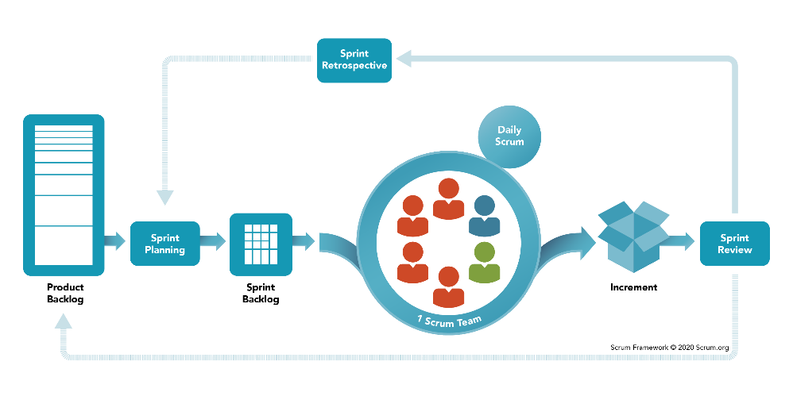

Figure 2 Scrum Framework (Scrum.org, 2020)

A scrum involves a development team, this is a group of professional members who develop, program and/or design and deliver the product, a Product Owner is the expert of the product and who represents the stakeholders, and the Scrum Master is someone who ensures the Scrum process is understood, organised, and followed (Muslihat, 2018). For the SQL Test Automation project, the product owners have been my industry supervisors Amit Sarkar and Alister Macgregor, while I have been a team of one developer who has developed and designed the project product outcome. While developing the product, I have also acted as the Scrum Master to make sure the Scrum process is followed with the support of my industry supervisors.

### Sprints

Iterations are made up of two to four-week sprints in which each sprint has a goal for a deliverable product (Business News Daily Editor, 2020), however as a team consisting of one person, I have been doing sprints of one to two weeks. The purpose of Agile is to move fast while releasing frequently and responding to the needs of the industry client, therefore a complete list of requirements before starting work is not needed, instead, work continues in a single direction with the understanding that the progression will change through the project (MacKay, 2019).

At the beginning of each sprint, there is a meeting where the Sprint planning occurs, this is to plan the upcoming sprint. Another meeting that occurs daily is the Daily Scrum, this meeting is usually around 15 minutes and the team discusses the previous day's successes as well as the prospects for the next day. At the end of each sprint, there is another informal meeting, which is called the Sprint review, it involves the scrum team presenting their increment of work to the stakeholders which are then used for feedback. The sprint retrospective meeting involves taking the feedback given from the previous Sprint and using it to determine further implements for the next Sprint (Muslihat, 2018).

Documentation is also needed as part of the evidence of planning and work done in the Scrum process. The Product Backlog and the Sprint Backlog are two artifacts that are everchanging with the sprints initiated and completed. The Product Backlog is managed by the Product Owner, a document where all the requirements are listed in order of priority for the viable product, it also includes all information regarding the products features, functions and any changes that should be made later potential releases. The Sprint Backlog contains the list of tasks and requirements that are to be completed within the next sprint.

### Pros and Cons

The Agile methodology has many advantages as well as many disadvantages for companies to keep in mind. The following are some of the pros and cons of the methodology (Henricksen, 2019):

|  |  |
| --- | --- |
| Pros | Cons |
| Easy to explain and understand and light framework. | The product results are expected at the end of each sprint, teams need to work faster/harder. |
| Feedback allows changes to happen and better adapt the product to the company. | Scrum implementations can fail due to many company reasons. |
| Important features are prioritised over features that will never be used. | The excessive embracing of change can lead to scope creep. |
| With scrum, the sprints are visible to all team members for them to work on. | Developers may not want to spend time on meetings. |

## Software Development Process

As this project involves the development of software, it uses the Software Development Process within each Sprint, a process made up of 6 phases, the following graph shows the phases in the cycle process:

Figure 3 Software Development Process (MacKay, 2019)

### Meeting and Planning

The first phase involves meeting your customer or stakeholder to analyse and plan for the project or sprint. The planning should include the connection of the project to the company’s goals, the resources and time required, the scheduling of tasks and cost estimation. Everyone involved in the project will need to be accounted for in the planning for the project to start efficiently. The planning will also involve the requirements, which includes the details of the product, the reasoning behind it and how it will come together according to the client (MacKay, 2019).

### Designing and Development

With the planning and requirements complete, the design and development can begin, this could include prototypes, user stories, wireframes, etc. The development of the software can then begin keeping in mind to avoid scope creep and building clean and efficient software according to the planning, requirements, and designs (MacKay, 2019).

### Testing and Evaluation

Testing can happen during the development phase while keeping track of bugs and errors. Once the features are complete and the product is ready, more in-depth testing is recommended before moving forward. Evaluation can happen and changes can then be issued for the next sprint. The process then restarts for the next sprint.

# Part B – Industry Practice

The following section describes the industry practice of this methodology that was observed while carrying out the project this includes examples and evidence of the project work.

## Overview

For this project, I have been completing the Software Development process for each sprint of the Scrum process, the Agile methodology framework. At the beginning of each sprint, I met with my industry supervisors to discuss goals, requirements, and the outcomes of what they need at the end of the sprint, as per this I was able to plan for what I needed to work on, I included the discussed requirements in a “Industry Backlog” excel spreadsheet.

As previously explained, the product owners have been my industry supervisors Amit Sarkar and Alister Macgregor, while I have been a team of one developer who has developed and designed the project product outcome. While developing the product, I have also acted as the Scrum Master to make sure the Scrum process is followed with the support of my industry supervisors.

The design and development phases were established by coding the product which involved Microsoft SQL Server 2017 and 2019, and tSQLt database unit testing framework within SQL Server, which allows for the implementation of unit tests in T-SQL, a proprietary extension to the SQL Server language.

I did manual testing while coding the product throughout the development phase, it was also tested by my industry supervisors during our sprint meetings which also involved the evaluation of the product for the next steps. The following sections explain these phases in greater detail with evidence of my work with steps taken according to (MacKay, 2019).

The meetings that occurred between each sprint were treated as the meeting for sprint planning, sprint review and sprint retrospective, altogether. Daily scrum meetings were not possible since my industry supervisors are also tutors at Ara Institute, therefore I did my planned and assigned work while they taught their courses, however, I did meet them or emailed them in between whenever I needed to ask them anything.

## Planning

Each sprint focuses on a product that is built within a sprint period, frequent planning and setting of goals allow the team to focus on objectives and increase productivity (Business News Daily Editor, 2020). For this project, I completed an excel spreadsheet called “Industry Backlog” that I used to plan my sprints, including the breakdown of all the tasks that I plan to complete by the end of each sprint, the status of each sprint changed from “not started” to “in progress” and “done” when completed. These steps were taken according to (MacKay, 2019). Appendix A1 to A7 shows evidence of task planning for all 7 sprints completed in this project, this has been taken from the Industry Backlog spreadsheet. Anything that was not started was passed onto Sprint in the next sprint.

Within the industry backlog spreadsheet, I also have another tab that accounts for the Sprint/Product Backlog. The Sprint Backlog involves the planning of the overall sprint and what requirements need to be established by the end of the sprint cycle. Appendix B1 shows evidence of the Sprint/Product Backlog from the Industry Backlog spreadsheet.

## Design and Development

As per the planning phase of the software development process, the design and development of the product can begin, the design phase can involve creating prototypes or wireframes using the requirements obtained and planned for what the product will look like and how it will function which will help code the product in the development phase (MacKay, 2019).

For the design of my products, I created simple low-fidelity wireframes using the task planning for each sprint. These wireframes helped guide me to how I needed to build the product within the Sprint cycle. Appendix C1 shows evidence of the final product wireframe, taken from Sprint 7.

With all the planning and designing completed, the development of the product according to the requirements of the sprint cycle can begin. This phase is known to be the most difficult and may consume a lot more time than what you allocate or may also become risky causing scope creep if not done cleanly and efficiently, according to (MacKay, 2019), this was true for me too because since tSQLt was a brand new unit testing framework for me, I needed to use a lot of time to understand the new T-SQL language and the features of the framework, however, the products produced with sprints till date have been done well, according to my industry supervisors. As evidence of the development phase, Appendix D1 to D7 shows screenshots of some code from each of the 7 sprints completed in this project, produced using Microsoft SQL Server Management Studio with SQL Server 2017 and unit testing framework tSQLt, and Microsoft Visual Studio 2019.

## Testing and Evaluation/Meeting

At the end of each sprint, the team meets to test and get feedback according to the Scrum framework and the software development process (MacKay, 2019), I met my industry supervisors at the end of each sprint to show and tell what I had done, and they tested it, this involved running the product code on various computers as per the user type and version of the software involved, for example, a test involved running product code on an Ara tutors user account (industry supervisor) using SQL Server 2017, and an Ara students user account (that’s me) using SQL Server 2017 and then SQL Server 2019. Appendix E1 shows evidence of different testing that occurred during the sprint meetings, these were signed off by the industry supervisors.

As per the testing, I was provided feedback for the evaluation of what I had done well and what I should do for the next sprint, from this I will be able to start the next sprints process. The following table shows evidence of all the sprint meetings for this project:

|  |  |  |  |
| --- | --- | --- | --- |
| Attendees | Sprint | Date | Time |
| Amit, Alister, Rob, Aditya | - | 7/04/2021 | 12:30 pm |
| Amit, Rob, Aditya | - | 9/04/2021 | 12:00 pm |
| Amit, Alister, Aditya | 1 | 15/04/2021 | 2:00 pm |
| Amit, Rob, Aditya | 2 | 28/04/2021 | 1:00 pm |
| Amit, Aditya | 3 | 12/05/2021 | 1:00 pm |
| Amit, Aditya | 4 | 26/05/2021 | 12:00 pm |
| Amit, Aditya | 5 | 3/06/2021 | 12:00 pm |
| Amit, Alister, Aditya | 6 | 10/06/2021 | 12:00 pm |
| Amit, Aditya | 6 | 11/06/2021 | 1:00 pm |
| Amit, Aditya | 7 | 16/06/2021 | 12:30pm |
| Amit, Aditya | 7 | 18/06/2021 | 12:00 pm |
| Amit, Aditya | Completion | 24/06/2021 | 1:00 pm |

# Part C – Reflections

The following section serves to present my reflections on the project. I have compared and contrasted the theory, observed practices and shown critical reflection from this project.

## Final Reflection

Throughout this semester, this course, and this project, I have gone through many ups and downs whether it be in terms of skills and knowledge, time management, workload or simply the anxiety of failure. At the beginning of the course, I had not obtained a project, after many weeks of searching, attending interviews and being rejected, I was offered an internal project by Amit and Alister at Ara Institute and by my luck, it involved databases, this was lucky for me because I did enjoy working with databases, however, it was going to be a lot more difficult than I thought, I was introduced to the tSQLt database unit testing framework for Microsoft SQL Server. I had not used SQL Server before, however since I did do BCPR203 Database Management Systems, I did know how to use MySQL and this helped me gain an understanding of the SQL Server and T-SQL languages, however, I had never used a database unit testing framework before, but it turns out most people had not also since this is a newly growing technology in the database area in the IT industry.

tSQLt had been a steep learning curve for me, I have had to take extra time to work on fully learning and understanding the tool and technologies to start doing actual work from Sprint 1, however, I was able to understand much of these tools and technologies for me to be able to finish this project successfully, I have learnt from my mistakes along the way. Some technical issues I faced along the way were the use of schema and databases, I started off using schema to collect tables, objects and data into it, however, I learnt that schema is unorganised, and tables tend to fall out of the collection, making it hard to make objects work together, from this experience, I tried using databases and this worked, all my tables and objects became organised, and my code worked perfectly.

Over the many sprints in this project, my tSQLt knowledge has expanded. On the first sprint, I was able to use a database with tSQLt to test a single query and get results, the second sprint involved multiple queries being tested at once, the third sprint involved less hard code as the answer SQL files and the testing script were separate, sprint four involved testing with the first real database “NORTHWIND” and even less hard coding with a separate model answer script, the fifth sprint involved the first packed product produced using C# and .NET framework where only single files tested, one after the other and the program was heavily hardcoded, the sixth sprint involved the second version of the packed product which now allowed for bulk upload and testing of student answers in a classroom altogether and finally the seventh and final sprint involved the portable package of the product to be deployed anywhere, refined UI and bug fixes and the creation of a product manual documentation. This shows the reflection of my journey and the product from single queries to multiple queries on multiple student answer scripts in a single program.

The other tool that I used was Visual Studio 2019 and the programming language C# with the .NET framework. I used these tools and technologies to package the code that I had written in previous sprints. There were many technical problems that I faced while trying to connect the SQL Server to the C# and .NET program, for example, the creation of the connection string which allows the connection of SQL Server instance and a database within, the installation of tSQLt framework from the program, the upload and execution of the model answer scripts, testing scripts and the student answer scripts, etc. I was able to overcome these problems by simply searching official Microsoft documentation online and/or online tutorials and help forums. Along the way, I fixed those problems and learnt from them, not only was the program developed in increments but my knowledge and skills also grew in increments as I researched and fixed each problem.

As the program evolved, I started doing real testing with real student answers provided to me by my industry supervisor, Amit, he needed the product to be able to upload multiple student answers and execute the results for them in bulk, till now I had been testing single student answers at a time and getting bulk results seemed extremely difficult to develop. I started writing C# and .NET framework code, doing this was another challenge for me and I was facing many problems such as many execution errors, however with the help of the internet and many hours later I was able to make the product bulk test a whole classroom of student answers in approximately one minute.

The project outcomes were unknown to me at the beginning of the project. From the project proposal, I did not have a clear understanding of what I needed to produce for the outcomes of this project, it took me time to not only learn the tools and technologies involved, but it also took me time to figure out the expected outcomes of this project, however by the halfway report, I had understood what I industry supervisors needed from me and I have been successful at meeting their requirements at the end of the project where I have produced the completed, viable and deployable product.

In terms of the implementation of the Agile methodology, Scrum framework and the software development process within each sprint, I was able to follow these processes throughout the project without any issues as explained in Part B of this document. My industry supervisors made sure that I was completing each sprint to standard with quality assurance and testing, they have been happy with my progress.

Even though this project has been a challenge for me, I have enjoyed working on it, learning new skills, and gaining knowledge with these processes, technologies, and tools. It has been a unique experience, something that I had never done before. It is my personal goal to develop a career, which will advance my practical experience and allow me to utilize these skills to the best of my ability. I look forward to starting my career in the IT industry.

# Appendix

## Appendix A – Task Planning for Sprints

### Appendix A1 – Sprint 1



### Appendix A2 – Sprint 2



### Appendix A3 – Sprint 3



### Appendix A4 – Sprint 4



### Appendix A5 – Sprint 5



### Appendix A6 – Sprint 6



### Appendix A7 – Sprint 7



## Appendix B – Industry Backlog

### Appendix B1 – Sprint/Product Backlog



## Appendix C – Design

### Appendix C1 – Sprint 7 Wireframe



## Appendix D – Development

### Appendix D1 – Sprint 1 Code

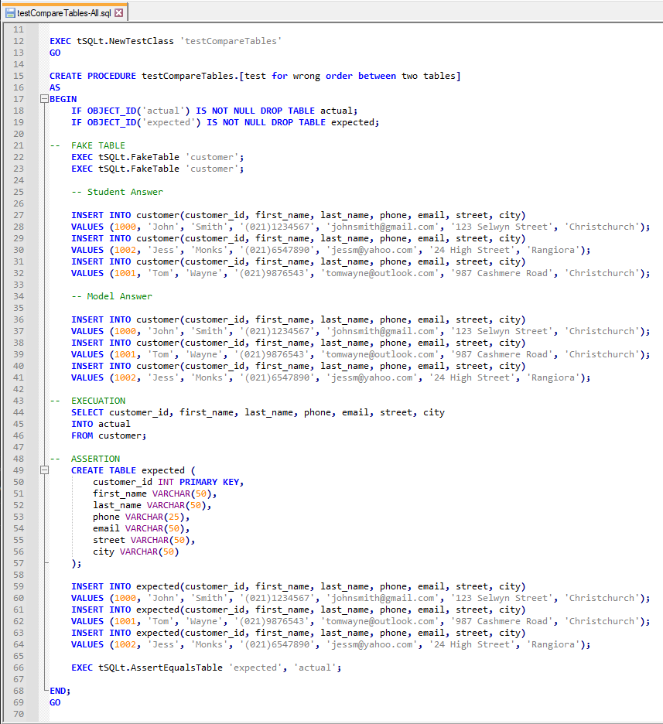

### Appendix D2 – Sprint 2 Code

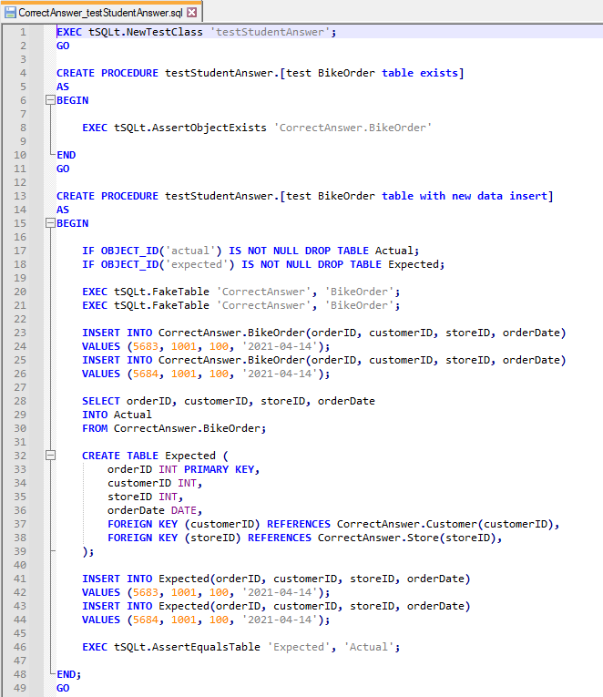

### Appendix D3 – Sprint 3 Code

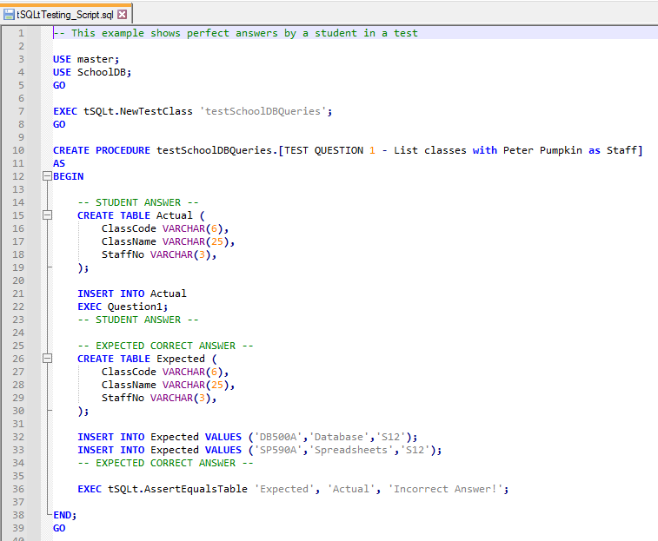

### Appendix D4 – Sprint 4 Code

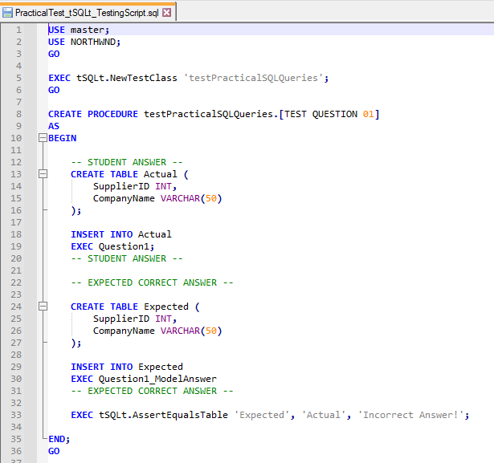

### Appendix D5 – Sprint 5 Code

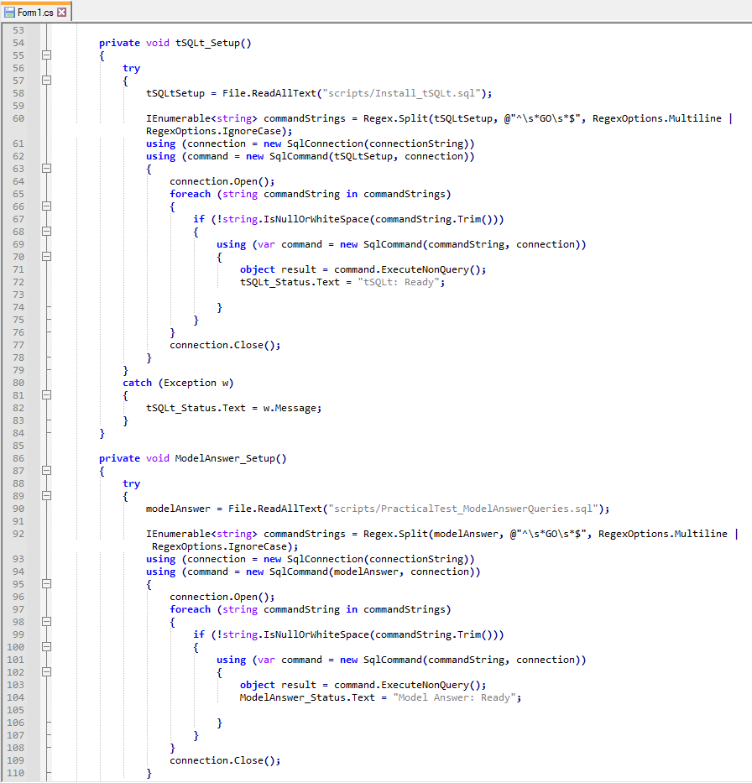

### Appendix D6 – Sprint 6 Code

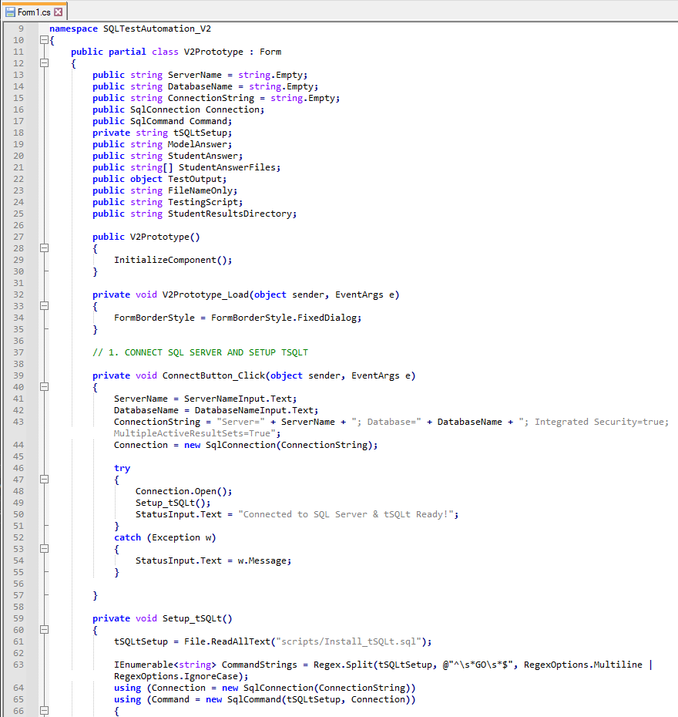

### Appendix D7 – Sprint 7 Code

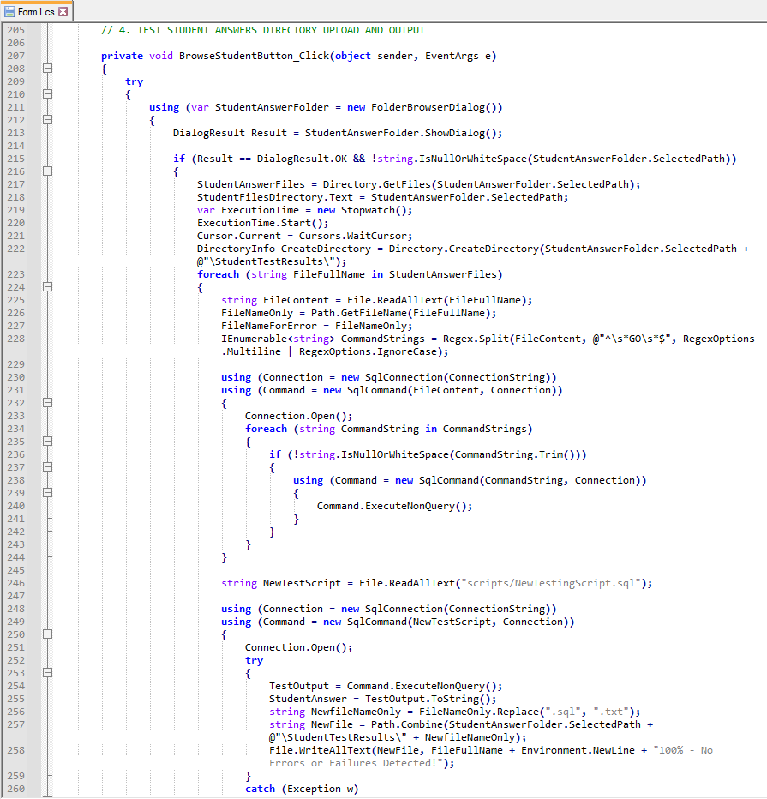

## Appendix E – Testing

### Appendix E1 – Testing Sign Off Sheet

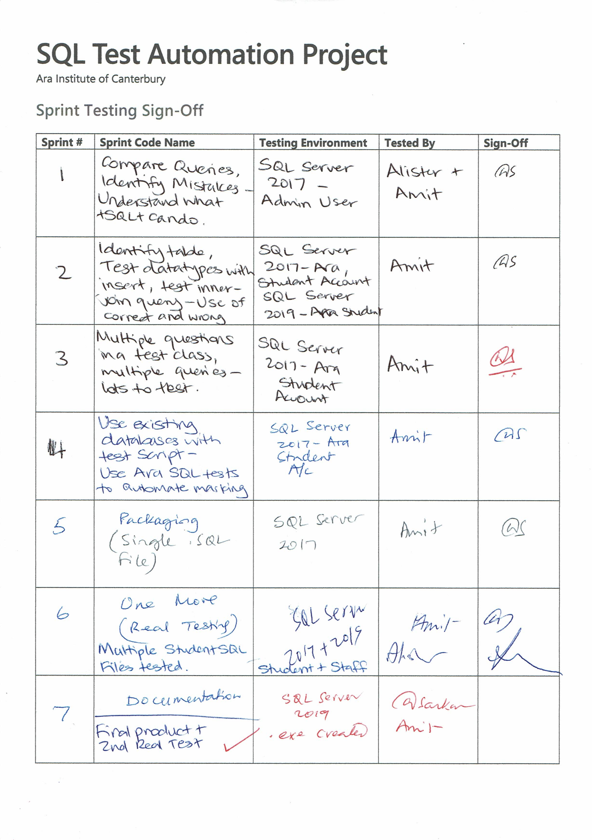

# Bibliography

Business News Daily Editor. (2020, February 25). *What Is Agile Scrum Methodology?* Retrieved April 3, 2021, from Business News Daily: https://www.businessnewsdaily.com/4987-what-is-agile-scrum-methodology.html

Henricksen, T. (2019, January 23). *Scrum pros and cons.* Retrieved April 4, 2021, from Medium: https://medium.com/@TomHenricksen/scrum-pros-and-cons-acf6b53b1ad6

MacKay, J. (2019, October 2). *Software Development Process: How to Pick The Process That’s Right For You.* Retrieved May 3, 2021, from Plan.io: https://plan.io/blog/software-development-process/

Muslihat, D. (2018, March 2). *Agile Methodology: An Overview.* Retrieved April 3, 2021, from Zenkit: https://zenkit.com/en/blog/agile-methodology-an-overview/

Scrum.org. (2020, November). *What is Scrum?* Retrieved May 4, 2021, from Scrum.org: https://www.scrum.org/resources/what-is-scrum